Response to Reviewers (mSystems00144-16R2)

We would like to thank the Reviewer #2 for the comments, as they have been really helpful to complete our work and make it clearer.

**Reviewer #2**

*Comments for the Author:*

*The authors have made significant improvements to the manuscript and addressed many of the reviewer comments. I think the new analyses included from the David paper have added a lot (e.g. following how parameters change as host health/behavior changes). However, there are still several issues that need to be addressed.  
  
General Comments:  
  
1) While it is clear that the language is much improved, the manuscript is still riddled with grammatical and compositional issues. I will enumerate some of these errors from the first paragraph of the Introduction to give an example, but will refrain from language-editing the entire paper, as this would take up too much of my time. I suggest the authors have another native-speaker, who is also scientifically literate, provide edits.*

* A new native-speaker specialist revisited the text and made significant changes.

*lines 47-50: This sentence feels off, with too many 'such as' and commas. The first clause of the sentence is strange, and could be put more simply. For example: 'The human microbiome is intimately linked to our physiology...'. Also, replace 'key-route metabolites' with 'key metabolites'.*

* Done

*line 52: replace 'affections' with 'afflictions' or 'conditions'*

* Done

*line 53: replace 'other multiple' with 'many other'*

* Done

*lines 52-55: Awkward sentence. Replace 'Current studies reveal' with 'Recent studies have revealed'. Replace 'microbiota also influences' with 'microbes also influence'. Replace 'and is related' with 'and are related'. Replace brain-gut-microbiome axis' with 'gut-brain axis'*

* Done

*lines 55-58: replace 'mystifying and elusive' with 'subtle' and delete 'which is hard to diagnose'. Replace 'closely related to' with 'associated with'*

* These lines have been rewritten attending to these suggestions.

*2) Your modeling approach and analyses are clearer now that you have filled in with more text. I am now convinced of the utility of you Taylor's Law fitting in defining community stability. However, there are still significant gaps. For example, you talk about phase transitions in F/V space. There are very formal definitions of phase transitions (e.g. first and second order) in physics. I see that you define the transition in terms of the Fokker-Plank equation, and that the two phase regions are defined by an 'order' parameter. Is the crossing of this phase-boundary non-continuous? What is the state variable that pushes the community to different locations in this phase-plane? Disturbance intensity/duration? You should bring more discussion of the phase space and how you define phase transition into the main body of the results and discussion.*

* We have added more text explaining the phase transition figure. The phase transition is continuous (second order in other classifications), and so it is the crossing of the boundary. The state variable is the composition. Any disturbance modifies the composition of the microbiota, with different compositions encoding different F and V (position in the phase space). We have shown that effective perturbations change V very significantly, and lead to phase transition of the microbiota from the ordered to the noisy. Our model can be solved analytically, which allows to a simple understanding of the different regimes, and in particular calculate the formula of the transition region. If V is sufficiently small compared to F, there is a maximum in the likelihood in the physical region (relative compositions larger than zero and smaller than one), i.e., there is a best composition solution of the differential equation, which is the ordered solution. On the contrary, if V is sufficiently large compared to F the maximum in the likelihood is outside the physical region), i.e., the best composition solution of the differential equation is at the boundaries (either zero or one) and all physical solutions have comparable likelihoods, which is the noisy phase]

*Why didn't you include all your time series in the V vs. F phase plot (Fig. 3). If you include all your data, how often do unhealthy people fall within the healthy range of phase space, and how often does the opposite occur? Would you consider Fig. 2 to be fairly equivalent to Fig. 3?*

* Fig 2 and Fig 3 are not equivalent. Fig 2 shows data only extracted from all the Taylor laws. Fig 3 uses the results from Fig 2 and the dynamical model to illustrate the trajectories in the phase space after when microbiota is perturbed. Fig 3 with all data is very busy and shows the effect “more is less”. We have included examples with the different cases found. All healthy people fall in the ordered phase, but not all unhealthy fall in the noisy phase. We could estimate these numbers, but we did not in this work because we are plugged with systematic errors due to sequencing which we need to better understand.

*Specific Comments:  
  
line 90: You seem to be saying that microbial dynamics 'affect' host health status. But I saw no attempt to infer causality in your results section. Be careful about implying causality.*

* Your point is totally right. The text has been changed to avoid implying causality.

*lines 106-105: Are you saying that Taylor's parameters are correlated with an independent measure of community stability? Or that you are assuming they are proxies for stability? Also, you should mention that V is the y-intercept in Fig. 1, while beta is the slope of the line (both in the manuscript and in the figure caption).*

* We are implying that Taylor’s parameters are proxies for stability. We have added further explanations in the results section. Now, it is mentioned in the text that V corresponds to the y-intercept and beta to the slope of the line.

*lines 113-115: Please provide a reference for this Medicare factoid. Also, delete 'stable such as, for example,' and replace with 'stable, similar to'.*

* Reference added to the text and grammar fixed.

*lines 125-126: Label axes with 'beta' and 'V' parameter names, for consistency.*

* Axis labels changed to V and beta.

*Figure 2: There seems to be a flaw in your zone of health. You've presented a 2-D Gaussian distribution around your 0-centered normalized results. However, I don't think this is correct. Conceptually, there shouldn't be any lower threshold on beta and V where you cross from healthy to unhealthy (just getting more and more stable as those numbers decrease). Very low beta and V are likely to be healthy. I would only expect samples in the upper-right quadrant to be 'unhealthy'. Thus, the boundary of the unhealthy zone should probably look like a rectangle with its upper right corner rounded.*

* This is not what we find in the data. There is a minimum V and beta for the data of healthy individuals. We obtain V and beta smaller than the region of healthy for the kwashiorkor cases, which seems to indicate that microbiota must have a minimum value to be healthy. So, we find that microbiota tends to have a sufficiently large variability, probably to accommodate the dynamics led by a changing environment. In other words, our results suggest that a too low variability is also related with an unhealthy state.

*line 156: Is there precedent in the literature for defining an organism's fitness as its recovery half-life? If so, please provide reference.*

* We have not found any reference in the literature referring to the fitness as the recovery half-life. That part in the text was introduced in order to clarify the physical properties of F.

*line 158: Are the V and beta parameters from the Langevin equation equivalent to the same parameter from Taylor's law? If so, please state. If not, please give this parameter a different name to avoid confusion. Also, how correlated are the F, V, and beta parameters for each of your model fits?*

* Yes, the V and beta parameters of both parts are equivalent. We have explicitly written it when introducing the Langevin Equation. We find that V and beta are positively correlated, as shown in Figure 2. F is little correlated with the actual V and beta, and depends mostly on the history of microbiota-host interactions.

*Figs. 4-5: Describe the panels showing DV and RV (and define these parameters) in the figure caption. How are you defining your medium-ranked stability islands? Quantitatively? Do you see a steady/linear decay in RSI as you move down in average rank? Is there a plateau at medium average ranks? Is there a non-monotonic trend? This is hard to see with just numbers. Maybe try plotting RSI as the width of your average rank colorbar, or show a line-plot with RSI on the y-axis and average rank on the x-axis.*

* Rank Variability (RV) and Differences Variability (DV) parameters have been mentioned in the captions of Figure 4, Figure 5, and Supplementary Figures S1 and S2. Together with RSI, the lector is referred to “Rank stability and variability” subsection in Material and Methods for details. In “Rank stability of the taxa” subsection in Results, we associate the concept of *rank-stability islands* to medium-ranked taxa whose RSI is roughly over 70%. In addition, to represent RSI both by numeric value (in percentage terms) and by a colormap scale, following the Reviewer suggestions, we have substituted the overall rank colorbar (it was dispensable as it was just showing the colormap used) by a line-plot showing the RSI on the x-axis for the elements ordered by global rank in the y-axis (so that the criteria for the order of the elements in the Figures has been kept). In this line-plot, the x-axis maximum value is 100%. The x-axis minimum value has been chosen as the lower RSI for the taxa shown, in percentage terms and floored to the nearest integer. Thanks to this new representation suggested by the Reviewer, we can observe a quasi-lineal decay in RSI as we move down in the overall rank, with some fluctuations (which are lower in the ordinary periods compared to the special period shown in Figure 4). In the medium-ranked taxa, those fluctuations, when are positive and significant (RSI surpasses approx. 70% threshold), they correspond to the mentioned *rank-stability islands*.

*line 214: You say you used the 'largest sampling' time series for Fig. 6. Is this still true after including the paper from David et al.? I think the female time series from the Caporaso paper is shorter than both the time series form the David paper. Also, you mention that you calculated beta and V, but only plot V. Why not show beta as well?*

* Correct. We have changed it in the results section. Beta plots are less informative given present errors because the central values change less in beta than in V, the range of variation of beta is quite small (between 0.7 and 0.8) compared to the error inferred. We added some plots in this reply to the referee, but we think they do not add much given the limitation in the number of figures.

Male’s gut from Caporaso *et al*., article.

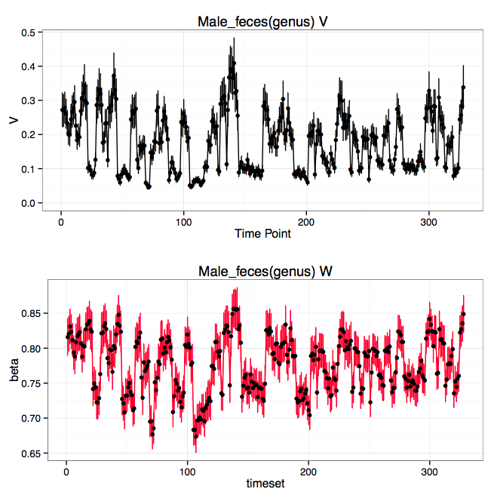

Female’s gut from Caporaso *et al*., article

